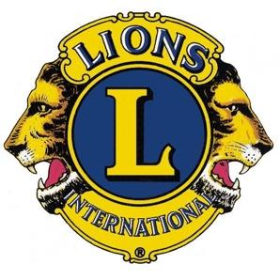 LIONS CLUBS INTERNATIONAL

District 13 OH 2

District Governor Patty Moorman

**OFFICIAL CALL TO CONVENTION**

District Governor Patty Moorman hereby issues the Official Call for the 2025 District 13 OH2 Convention, to be held March 14-16, 2025, at the Wyndham/Doubletree Hilton, 1100 Crocker Road, Westlake, Ohio, for the purpose of recognizing the efforts of our Lions, providing Lions learning sessions, discussing district business, holding district elections, and remembering our Lions that have passed away. The Convention Business Meeting will be held Saturday, March 15, 2025 beginning at 2:00 PM.  The Elections will follow the business meeting. The passing of the Gavel to the newly elected District Governor will occur at the conclusion of the Grand Banquet.

This call is issued in accordance with Article VI, Section 2 of the International By-Laws and the Multiple District 13 Constitution & By-Laws.

Patty Moorman, District Governor

Lions Clubs International Multiple District 13 OH2

pattymoorman@yahoo.com