13 OH2 STEPS WALK 2022
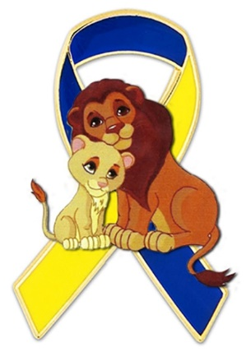
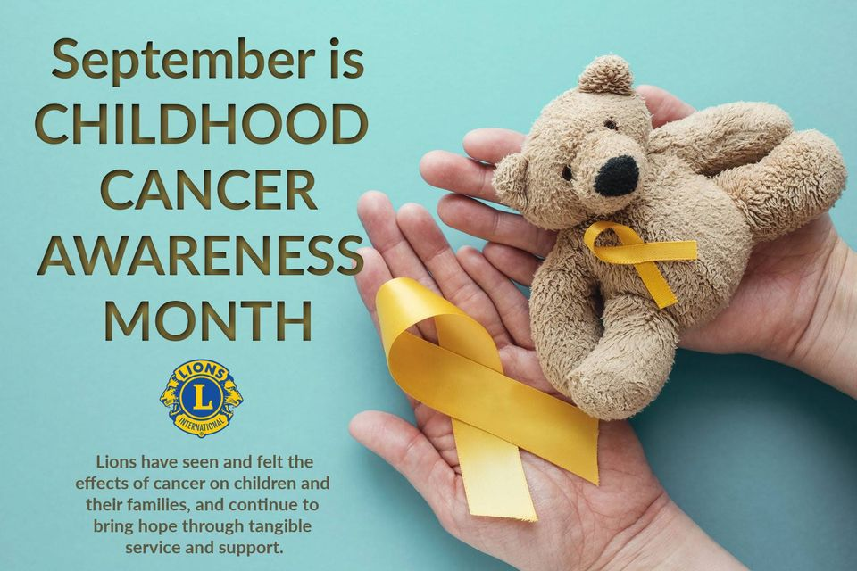
- 100% of the money raised will go to pediatric cancer research and support of affected families.
- Childhood cancer survivors are twice as likely to suffer chronic health conditions.
- 47 children per day are diagnosed with cancer.
- 1/285 children in the U.S. will be diagnosed with cancer by age 20.
- Only 4% of the money annually spent on cancer research and treatments are directed towards treating childhood cancer. We can better this!
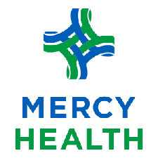

SUNDAY, SEPTEMBER 25, 2022
Lake Lamberjack & Lake Mottram
at FOSTORIA CITY PARK
1 Mile Walk at 10 AM
$25 donation per Registration (includes t-shirt if in by Sept 10)
Families Welcome
Virtual Walkers encouraged to participate

