13 OH2 STEPS WALK 2021
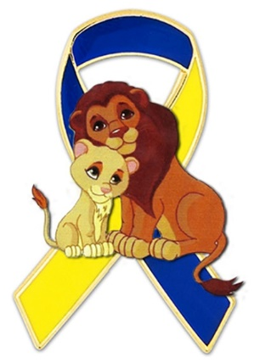
- 100% of the money raised will go to pediatric cancer research and support of affected families.
- Cancer is the number 1 cause of death by disease among children.
- 43 children per day are diagnosed with cancer.
- 1/285 children in the U.S. will be diagnosed with cancer by age 20.
- Only 4% of the money annually spent on cancer research and treatments are directed towards treating childhood cancer. We can better this!
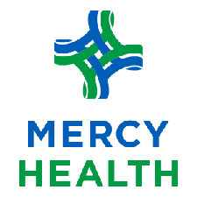

SUNDAY, SEPTEMBER 19, 2021
Lake Lamberjack & Lake Mottram
at FOSTORIA CITY PARK
5K Run & 1 Mile Walk at 10 AM
$25 donation per Registration (includes t-shirt)
Families Welcome
Virtual Walkers encouraged to participate
Registration and details to come in August

