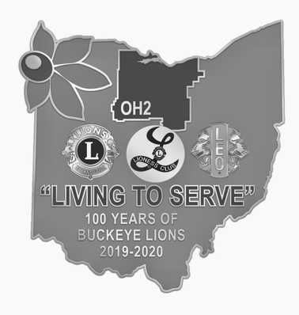
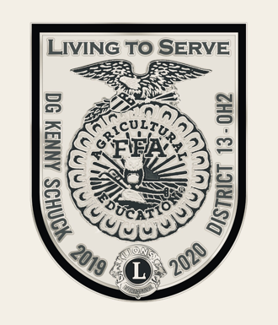
Dear Lions and Friends,
OH2 DISTRICT CONVENTION
March 20-22, 2020
Holiday Inn
15471 Royalton Rd, Strongsville, OH 44136

The time has come to register for the much anticipated 2020 OH2 District Convention 100 YEARS OF BUCKEYE LIONS! I hope that you are as excited as we are about the coming weekend of socializing with old friends and making new ones. We will be celebrating the accomplishments of Lions through out the district, and you will have the opportunity to learn new ideas to take back to your club. Governor Kenny and I believe we have put together a jam packed weekend of activities that will appeal to all Lions young or old, new or long time members. This weekend is for and about you, the Lions of OH2. I hope every Lion in the District will come to Strongsville and celebrate with us.
We are fortunate to have so many wonderful and hard working Lions in this district, and at the Saturday Awards Luncheon we will recognize many of the individuals and clubs for their accomplishments. This year, Governor Kenny will be recognize an outstanding Lion from each Zone at the Friday Night Kickoff Celebration, and one of those will become the OH2 Lion of the year at the Grand Banquet on Saturday evening. Throughout the weekend we will also recognize the Lions who have worked so hard and contributed so much to help the District this year.
Part of the goal of the Friday Night Kickoff is to start the weekend off with a bang. What better way to welcome new Lions to our organization. We invite clubs to recruit new members and bring them to convention and particularly the Kickoff. Let us know and we will include them in our induction ceremony. Any new members this Lions year and accompanying family that attend only Friday night are not required to pay a registration fee whether or not they are being inducted. If your club has a Melvin Jones Fellowship to present we will hold an induction for that also on Friday night. Please let us know in advance for new member and MJF inductions.
Our international guest for the weekend will be International Director Gary Brown along with his wife Lion Barbara. The Browns are from Cape Vincent, New York. We look forward to hearing from them throughout the weekend. Club Presidents and their spouses are invited to attend a special get together Saturday immediately following the Awards Luncheon to hear from ID Gary about LCI. This program is limited to Club Presidents and their spouses. If a club does not have the President present an alternate may attend.
Great programs have been lined up to entertain and inform you. Beginning Friday night with special guest speaker Zane Gross. Zane is a Wendy’s restaurant’s franchisee and founder of ZG Leadership Enterprises. This will be a motivating and informative event.
Seminars on Saturday are going provide you with a broad range of information. Saturday morning while some attend the district business meeting. Two of OH2’s newest members will be giving a presentation on Suicide Prevention and How Lions Can Help. Although they are new to our organization Lion Adrianna and Lion Colleen have had a long involvement in working with those at risk.
Ever wonder what it is like to participate at a higher level in Lionism, the things you would see and do, the people you would meet? Past International Director Steve Sherer and Lion Mary Ellen have been involved from their Dover Lions Club home in Ohio to International Director and many involvements in between and ever since then. PID Steve is currently serving as 1st VP of the Lions International Pin Traders Club, as well as on the advisory committee to the USA/ Canada Leadership Forum. Come hear about the joy and challenges of going above and beyond.
Have you considered attending Lions Day at the United Nations, Lions Day at the White House, International Convention, or any of the many other experiences, conventions, and seminars available through Lions? PDG Micheal Gibbs, from Rushsylvania, Ohio has participated in many of these programs and will be giving an informative preview of what these activities are all about.
PID Cindy Gregg is from Bells Vernon, Pennsylvania and will be joining use to discuss the membership recruiting and retention challenges facing our clubs in the next decade. PID Cindy is currently the Area Global Action Team Coordinator for MD14 (Pennsylvania), MD24 (Virginia), and MD29 (West Virginia). She previously served as the Global Membership Team Area Coordinator for an area including Ohio until the recent realignment.
Past Council Chair Dave Gauch is from Garrettsville, Ohio in OH4. He has participated in several LCI training courses and is now training Lions around the country. Successful clubs need leaders at all levels, from committee chairs to President. PCC Dave will be discussing leadership development at the club level and how we can encourage members to step up and take charge.
Although we are not having a Scrapbook contest this year, clubs are more than welcome to bring theirs to show everyone what your club has been doing. If your club has a project that it wants to promote, you can bring a display board to set on tables we will have for this purpose.
We are wanting to put together a slide show of OH2 Lions in action. You can send me pictures on a disc, drive, or by email. If by email, please only send about five at a time. JPEG format is best for this activity.
To maintain a quality convention and still keep the cost as low as possible, we need your assistance. Through the silent auction and clubs bringing door prizes we are able to cover some of the costs and also enhance the convention experience for everyone. Please consider bringing items for the auction and door prizes. We are having a special basket contest. This year we ask clubs to bring a gift basket for the silent auction. The baskets will be voted on and the winning club will receive special recognition. I look forward to your entries.
We are having a special early registration contest this year. The first 150 registrations will be entered into a drawing to be held at convention. The winner will receive their registration refunded. To be fair, all registrations I receive the day that the 150th one is received will be entered. Make sure your clubs registration is in early to qualify.
Governor Kenny would also like for those clubs that are participating in the District Weight Loss Challenge to send in an updated weight loss record so that he can report on the District progress and standings.
I have heard about the “Good Old Days” of 800 people at convention. I don’t believe that the Holiday Inn is able to hold quite that many, but the fun and excitement of convention is directly affected by the number of members attending. The more people there are to interact with the more enjoyable it is for everyone. With larger crowds we can provide larger programs. This year, help us to make convention as great as possible and that begins with you being there!
I haven’t even mentioned the Euchre Tournament on Friday night or how the hospitality room will be involved in the Kickoff Celebration as well as open Saturday night, the Necrology service on Sunday, and the election of the next Governor.
We are still in the process of hopefully adding even more to an already packed weekend. So watch for updates. I look forward to meeting you all at Convention!

2020 Convention Chair
Stephanie Schuck
1126 Twp. Road 1875
Ashland, Ohio 44805
419-282-0053
Lionsoh2convention@gmail.com

