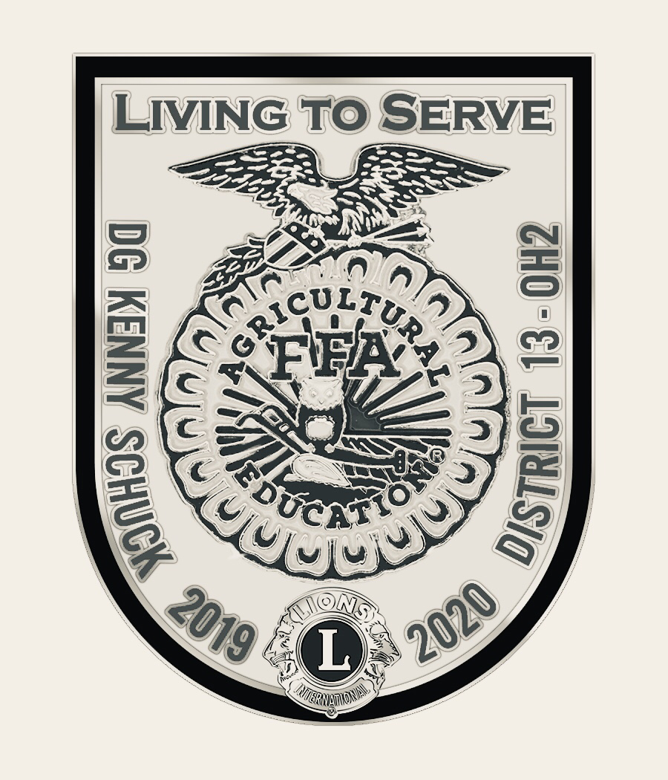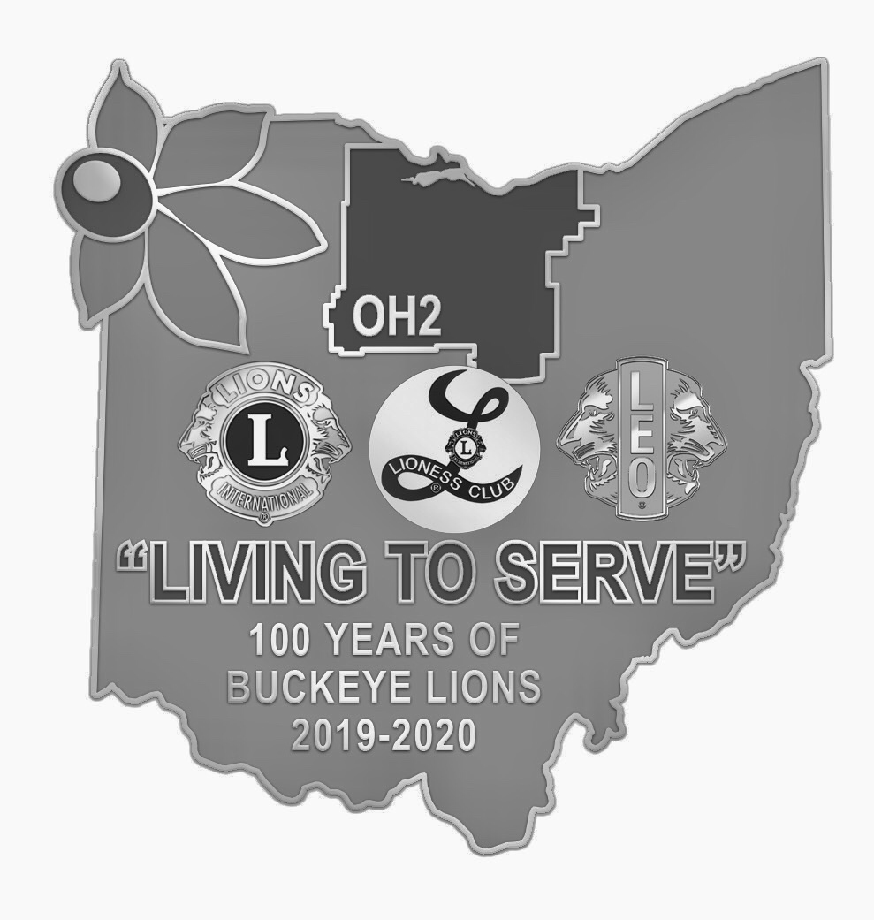
District 13-OH2 Convention
Schedules of Events
Holiday Inn – Strongsville, OH.

Friday March 20, 2020

3 p.m. to 6 p.m. Registration

3 p.m. to 6 p.m. Delegate Certification

3 p.m. to 6 p.m. Silent auction – Donations accepted. Hosted by the North Ridgeville Lions

3 p.m. to 6 p.m. Euchre Tournament Registration

6:15 p.m. to 6:30 p.m. Line up for Parade of Banners (Banners will remain in place for weekend. Any banners that arrive later will be placed in line.)
6:30 p.m. to 8:30 p.m. Convention Kick Off Celebration : New Member and Melvin Jones Inductions, SPECIAL GUEST SPEAKER ZANE GROSS, and much more!

8:30 p.m. to 11:00 p.m. Hospitality Room & Silent Auction Open

8:30 p.m. to 10:30 p.m. Euchre Tournament hosted by the Plymouth Lions Club

Saturday March 21, 2020

Breakfast on your own - Up to two breakfast buffets included with each room per night.

8:30 a.m. to 9:00 a.m. Delegate Certification
8:30 a.m. to 11:00 a.m. Registration

8:30 a.m. to 11:00 a.m. Silent Auction Open
9:00 a.m. to 10:30 a.m. District Business Meeting

9:00 a.m. to 10:30 a.m. Special Seminar: “Suicide Prevention How Lions Can Help”. with Lions Adrianna Anderson and Colleen Runion-Alkire
11:30 a.m. to 1 p.m. Awards Luncheon
1:15 p.m. to 2:00 p.m. Club Presidents meet with International Director (This is open to all Club Presidents and their spouses or one representative)

1:30 p.m. to 5:30 p.m. Registration
Delegate Certification
Silent Auction Open

2:15 p.m. to 3:20 p.m. Seminar 1: “ One Couple’s Journey in Lionism”. with PID Steve & Lion Mary Ellen Sherer
Seminar 2: Seminar on Membership with PID Cindy Greg
3:30 p.m. to 4:20 p.m. Seminar 3: “Adventures in Lionism” with PDG Micheal Gibbs

Seminar 4: Seminar on Leadership with PCC Dave Gauch
6 p.m. to 8:30 p.m. Grand Banquet

9 p.m. to 10:30 p.m. Silent auction

½ Hour after Banquet to 11:00 Hospitality rooms Open

10:00 p.m. Pick up Peace Posters, Scrapbooks and Display Boards

10:30 to Midnight Silent auction – pick up purchases

Sunday March 22, 2020

Breakfast on your own - Up to two breakfast buffets included with each room per night.

8 a.m. to 9:30 a.m. Registration
Delegate Certification

8:30 a.m. to 9:30 a.m. Worship and Necrology services

10:00 a.m. Business Meeting continues & Elections

11:30 a.m. Adjourn

12:00 p.m. Cabinet Appreciation Luncheon

