“Service through Leadership”
Constitutional Area 1B GLT Newsletter

Vol. 2 Issue 8 March, 2017

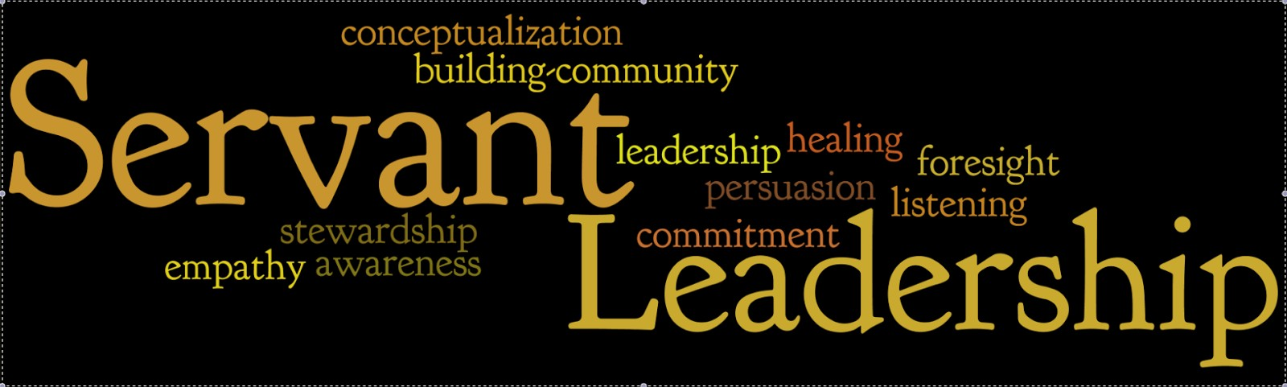

Question - What do the following eight leaders have in common?
1. George Washington
4. Abraham Lincoln
2. Martin Luther King Jr 3. Howard Schultz—CEO of Starbucks
5. Mother Teresa
6. Dan Cathy - CEO of Chick - Fil - A
7. Albert Schweitzer 8. Cheryl Bachelder - CEO of Popeyes Answer - All are or were practitioners of the philosophy of Servant Leadership.
For an organization that has the motto of “We Serve” I can not think of a more appropriate philosophy
of leadership. As you can guess this issue of the GLT Newsletter is devoted to information about the phi- losophy of Servant Leadership. I would also suggest that you go to the Lions Learning Center and take the course on Servant Leadership.
PDG Fred Breyer
THE SERVANT AS LEADER BY ROBERT GREENLEAF
While servant leadership is a timeless concept, the phrase “servant leadership” was coined by Robert K. Greenleaf in The Servant as Leader, an essay that he first published in 1970. In that essay, Greenleaf said: “The servant-leader is servant first… It begins with the natural feeling that one wants to serve, to serve first. Then conscious choice brings one to aspire to lead. That person is sharply different from one who is leader first, perhaps because of the need to assuage an unusual power drive or to acquire material pos- sessions…The leader-first and the servant-first are two extreme types. Between them there are shadings and blends that are part of the infinite variety of human nature.
“The difference manifests itself in the care taken by the servant-first to make sure that other people’s highest priority needs are being served. The best test, and difficult to administer, is: Do those served grow as persons? Do they, while being served, become healthier, wiser, freer, more autonomous, more likely themselves to become servants? And, what is the effect on the least privileged in society? Will they benefit or at least not be further deprived?“
A servant-leader focuses primarily on the growth and well-being of people and the communities to which they belong. While traditional leadership generally involves the accumulation and exercise of power by one at the “top of the pyramid,” servant leadership is different. The servant-leader shares pow- er, puts the needs of others first and helps people develop and perform as highly as possible.

How to Become a Servant Leader

According to Larry C. Spears, former president of the Robert K. Greenleaf Center for Servant Leadership, these are the 10 most important
characteristics of servant leaders: Listening.
Empathy. Healing. Awareness. Persuasion.
Conceptualization. Foresight.
Stewardship.
Commitment to the growth of people.
Building community.
Once you've decided to prioritize other people's needs over your own in the long term, you can work on developing your skills in each area. Let's look at how you can do this.

Listening
You'll serve people better when you make a deep commitment to listening intently to them and understanding what they're saying. To improve your listening skills , give people your full attention, take notice of their body lan- guage, avoid interrupting them before they've finished speaking, and give feedback on what they say.

Empathy
Servant leaders strive to understand other peo- ple's intentions and perspectives. You can be more empathetic by putting aside your view- point temporarily, valuing others' perspectives, and approaching situations with an open mind.

Healing
This characteristic relates to the emotional health and "wholeness" of people, and involves supporting them both physically and mentally.

First, make sure that your people have the knowledge, support and resources they need to do their jobs effectively, and that they have a healthy workplace . Then take steps to help them be happy and engaged in their roles.

Self-Awareness
Self-awareness is the ability to look at yourself, think deeply about your emotions and behav- ior, and consider how they affect the people around you and align with your values .
You can become more self-aware by knowing your strengths and weaknesses , and asking for other people's feedback on them. Also, learn to manage your emotions , so that you consider how your actions and behavior might affect others.

Persuasion
Servant leaders use persuasion – rather than their authority – to encourage people to take action. They also aim to build consensus in groups , so that everyone supports decisions.
There are many tools and models that you can use to be more persuasive, without damaging relationships or taking advantage of others. You should also build your expert power – when people perceive you as an expert, they are more likely to listen to you when you want to per- suade or inspire them.

Conceptualization
This characteristic relates to your ability to "dream great dreams," so that you look beyond day-to-day realities to the bigger picture.
If you're a senior leader in your company, work through and develop a robust organization- al strategy . Then, whatever level you're at, cre- ate mission and vision statements for your team, and make it clear how people's roles tie in with your team's and organization's long-term
objectives. Also, develop long-term focus so that you stay motivated to achieve your more distant goals, without getting distracted.

Foresight
Foresight is when you can predict what's likely to happen in the future by learning from past
(Continued on page 3)

(Continued from page 2)
experiences, identifying what's happening now, and understanding the consequences of your decisions.
Also, learn to trust your intuition – if your in- stinct is telling you that something is wrong, listen to it!

Stewardship
Stewardship is about taking responsibility for the actions and performance of your team, and being accountable for the role team members play in your organization.
Whether you're a formal leader or not, you have a responsibility for the things that happen in your company. Take time to think about your own values, as well as those of your organiza- tion, so that you know what you will and won't stand for. Also, lead by example by demonstrat- ing the values and behaviors that you want to see in others, and have the confidence to stand up to people when they act in a way that isn't aligned with them.

Commitment to the Growth of Peo- ple
Servant leaders are committed to the personal and professional development of everyone on their teams.
To develop your people , give them the skills they need to do their jobs effectively. Also, find out what their personal goals are, and see if you can give them projects or additional responsi- bilities that will help them achieve these.

Building Community
The last characteristic is to do with building a sense of community within your organization.
You can do this by providing opportunities for people to interact with one another across the company. For instance, you could organize so- cial events such as team lunches and barbecues, design your workspace to encourage people to chat informally away from their desks, and ded- icate the first few minutes of meetings to non- work-related conversations.
Encourage people to take responsibility for their work, and remind them how what they do contributes to the success and overall objec- tives of the organization
From "Character and Servant Leadership: 10 Characteris- tics of Effective, Caring Leaders" by Larry C. Spears, pub- lished in "The Journal of Virtues and Leadership," Vol. 1, Issue 1.

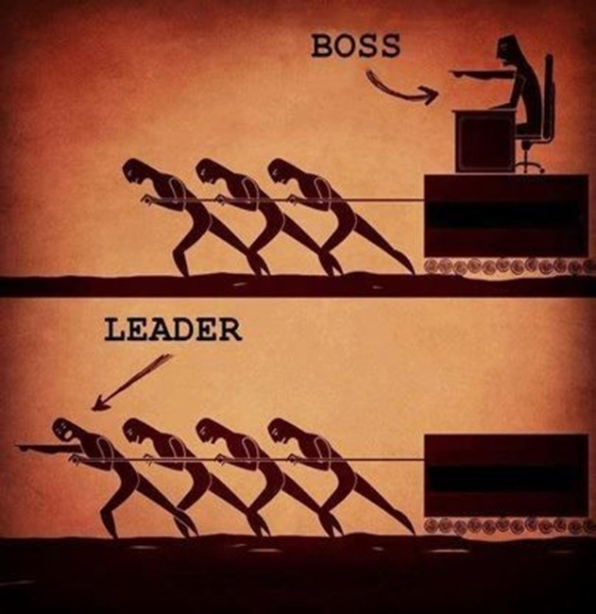

(Continued from page 4)
prioritize the sharing of unique experiences over career advancement. It’s a part of the ethos these younger workers exude, and I find it inspiring.
When you get interested in your employees and what matters to them specifically, you open the door to leading them. When you take the approach of a servant leader with the millennial generation, they will respond.
4. Commit and believe.
Traditionalists might argue that leadership is all about issuing orders with clarity and fairness. I don’t believe that anymore. I believe it’s more about showing people what they’re capable of, mapping that to your company’s direction and then letting them go to work.
It might seem counterintuitive because it cedes some perceived control. But in the end, it produces greater results. It’s a philosophical investment, re- quiring a commitment and belief that the payoff will come. In my years of servant leadership, I’ve seen it pay off in spades.
In the end, the servant leader -- the one who knows the troops on a deeper level -- truly wins. As Green- leaf, himself has said, “The difference manifests it- self in the care taken by the servant first to make sure that other people’s highest priority needs are being served. The best test, and difficult to adminis- ter, is: Do those served grow as persons?”

This article was written by Todd Wolfenbarger and appeared in Entrepreneur Magazine .

Why Leaders Should View Themselves as Servants

Twenty years ago, I received a unique gift. This gift impacted my career by introducing me to a servant leadership model I’ve tried to emulate since.

I was living in Seattle and had taken off for Christ- mas Eve. It was a typical December afternoon in the Northwest -- cold and rainy -- and I was out on my front porch with my young daughter, sprinkling homemade magical glitter oats along the path for Santa’s reindeer that night. My little girl was loving the adventure, and so was I.

Amid our fun, I looked up as an unknown SUV pulled into our driveway. To my surprise and mild discomfort, my boss -- our company’s CEO -- got out of the car. After exchanging greetings, he knelt next to my daughter and asked, “What does your daddy want for Christmas?” Taylor said, “He wants a bike.” My boss smiled, opened the back of his SUV and pulled out a mountain bike with a bow on it.He had called my wife in the weeks before (as he had with all of his direct reports) and asked her if there was a Christmas gift -- something I really wanted -- that he could get for me. To say I was grateful and im- pressed would be an understatement.

In the years since, I’ve duplicated his efforts with my own team and have received similar sentiments in return. As much as my team appreciated the ex- perience, though, I found that I loved the style of leadership even more.

The term “servant leader” was first coined by Robert Greenleaf in a 1970 essay, and it de- scribes leaders who seek to serve first, accepting that true leadership will be the result.

As the years, have gone by, I’ve become convinced of this approach. I believe in the concept because I’ve experienced its effectiveness from both sides of the equation.

Looking to try the approach for yourself? Here are four quick ways to begin:

- Learn something specific and important about every person you lead.
There’s a writing tip I love called “naming the dog.”
Calling the dog Sparky instead of just “the dog” ends up mattering. Why? Because the specificity creates connotation, context and nuance -- all important factors in writing well.

Specificity in servant leadership is also important. Knowing personalized details of those you lead, es- pecially those who show personal motivation, can make a big difference.

For example, I work with someone who, when told to do something in a very specific way, creates a sit- uation that nearly forces him to go the other direc- tion. He’s important to our team, and knowing this about his character, I try very hard never to issue him any direction or feedback in a hyper- authoritative or declarative manner. To another person on my team who craves specific instruction, this approach would be frustrating. The key is to know those you lead specifically so you can serve them best.

- Take action yourself, and let the credit go somewhere else.
Seth Godin’s book Poke the Box examines the need for starters in organizations -- the people who take initiative, even when they don’t have an edict to do so. According to Godin, initiative is the birthplace and differentiator of today’s workplace leadership.

There are many reasons that people fail to start something new or act now, but one of the biggest is a desire for credit (or, conversely, to avoid blame). Godin’s solution? Give the credit away. Worry about taking action, and use the positive results as a gift for those you lead. It may seem counterintuitive, but this is the heart of servant leadership: As you help others succeed, you become more successful your- self.

- Find a millennial in your organization to work alongside.
I work with a lot of people who are in the first or second jobs of their careers, and I’m learning so much from them. For example, many in this group
(Continued on page 3)

